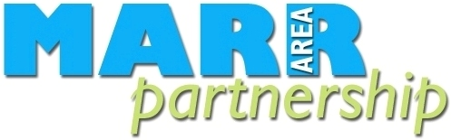

Building strong, resilient, and supportive communities where people take responsibility for their own actions and how they affect others.

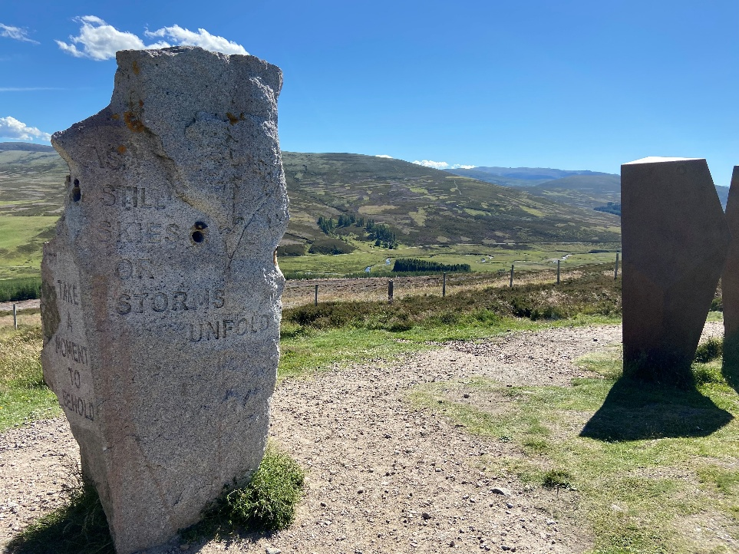

Annual Report 2025-26

Our Vision:
MAP exists to support the needs of Marr’s communities and third sector organisations through the delivery of high quality, entrepreneurial and inclusive support. It is a financially and environmentally sustainable organisation adding clear identifiable value to projects and service provision across the area through the actions of its dedicated staff and Board. It is widely recognised and respected for what it provides to communities and partners.

MAP’s mission is to support Marr communities to improve their quality of life through third sector action.

MAP’s values revolve around informing, guiding, and supporting third sector endeavours to improve the quality of life of Marr residents though an inclusive approach that pays particular attention to the needs of the least advantaged people and communities.
Contents

Introduction | 3
Chairs Foreword | 3
Treasurers report | 4
Our team | 5
Agreements | 6
Our work | 7
MAP in partnership | 10
IGS | 11
Future plans | 12
Summary | 12
Thanks | 13
Appendix 1  Cairngorms National Park Authority Report | 14

Introduction

This report covers the period from 1 April 2025 to 31 March 2026 and highlights the breadth and impact of activities delivered by staff and volunteers of Marr Area Partnership (MAP).

Throughout the year, MAP has continued to play a vital role in supporting communities across the Marr area, working collaboratively with local people, partner organisations, and public agencies. Our work aligns with the priorities of the Scottish Government, the Cairngorms National Park Partnership Plan, and the Aberdeenshire Community Planning Partnership.

Central to our approach is a commitment to “supporting communities,” with a focus on enabling the following local outcome:

“Successful, achieving, and inclusive communities with the confidence, capability, and capacity to tackle the issues that matter most to them.”

This report demonstrates how MAP has contributed to this outcome by empowering individuals, strengthening community resilience and supporting locally led initiatives that make a meaningful difference across the Marr area.

Chair’s Foreword

The Marr Area Partnership has had a great year. We have four very dedicated Development Officers operating across the Ward. They assist a vast number of community groups across many sectors. We welcome Tim Stephen as the new Marr Area Manager and look forward to working with him for many years to come. During the year, we said farewell to Hilary English, the Marr Community Planning Officer, we wish Hilary all the best with her future plans. At the same time, we are pleased to welcome Debi Weir to the role and look forward to working with her.

We remain very grateful for the funding we receive from both Aberdeenshire Council and The Cairngorms National Park.

Our office in Ballater, generously provided by the National Park, continues to act as an important hub for engagement. We welcome visitors most Wednesday mornings and encourage community members to connect with us.

The Marr Community Food Project has been a tremendous success, supporting many local people and culminating in a well-attended Food, Fuel and Futures seminar.. This year we concluded our very successful log bank which operated for 4 years but we felt the time was right to hand over the responsibility for distributing firewood to the local hubs that have been set up. We have helped many households who due to difficulties welcomed some nets of dry logs from our Coull yard.

We are all aware of the challenges of local authority and Government funding so decided we needed a source of sustainable funding going forward. Thanks to a brilliant idea from our Development Officer Lyza Riddell, we have now opened the Marr Charity Shop in Alford. We recently held a well-attended opening ceremony and the delightful staff and volunteers under the excellent direction of Rona the manager look forward to receiving your donations. Both Janice Smith and Jim Bruce, together with Lyza, have also put in and continue to put in many hours of dedicated support. We also had terrific support from the Mens Shed.

I would like to thank our officers for going above and beyond in support of the work of the Partnership and also the unfailing support of our volunteer Board members.

Treasurers Report

The Partnership has maintained a stable financial position to year ended 31st March 2025, continuing to manage resources carefully while responding to increased demand for services.

We remain extremely grateful for the continued financial support of Cairngorms National Park and Aberdeenshire Council. Their investment enables us to deliver essential services and respond to emerging community needs.

Income
Total income for the year was £81.822.00, generated from a combination of:
- Core funding from Cairngorms National Park
- Core funding from Aberdeenshire Council
- Grants and project-specific funding
- Donations

Expenditure
Total expenditure for the year was £72,123.00, allocated across:
- Staffing and Development Officer support
- Project delivery
- Operational costs
- Community grants and support funding

Our Team

Lindsay Gallagher, Administrator/Development Officer
Lindsay works 25 hours per week and leads on administration and bookkeeping for Marr Area Partnership, ensuring the smooth day-to-day running of the organisation. Working closely with the Treasurer, she supports effective governance, coordinating quarterly Board meetings and the Annual General Meeting, and ensuring compliance with reporting requirements.

Lindsay is the main point of contact for the Initiative Grant Scheme, supporting the administration of £5000 in funding and assisting 7 community groups/projects across Marr this year. See under IGS for more details. She also serves as Secretary for the Braemar Hydro Fund, contributing to the distribution of £30000 to 14 local initiatives in 2026.

As a Trustee of Cairngorms Trust, Lindsay strengthens links between organisations and helps amplify support for community-led projects across the area.

In her role as Development Officer this year, Lindsay has supported the communities of Braemar and Strathdon to update their Community Action Plans, engaging with residents/stakeholders and helping to identify key priorities/actions. She has also supported the establishment of the new charity shop in Alford.

Kate Redpath, Development Officer
Kate works seven hours per week and is responsible for the MAP weekly community bulletin, available via email subscription and on the MAP website. The bulletin shares updates from Aberdeenshire Council, Marr Community Planning Partners, Scottish Government, the Cairngorms National Park, and many third sector groups. Opportunities for funding, volunteering, employment, and to have your say via community engagement initiatives are some of the key items included each week. Kate supports Lyza with delivery of priorities 1 and 5 of the Marr Community Food Plan.

Cat Houston, Development Officer
Cat works 10 hours a week, however over the winter (Nov-Mar) she has had another 10 hours funded by the AVA's Community Mental Health and Wellbeing Fund to run Ballater’s weekly warm space, Toasty! for the last two years. Within that grant she has also established a working relationship with Ballater’s Evergreen Club (over-50s), and more recently the Wednesday Group (recovery/isolation) and Ballater Older People’s Association (over-50s) to assist them all with compliance, governance, publicity and fundraising.

Cat has a particular focus on Village Halls and continues to work using the established email database and Facebook group to help connect and support individuals and groups involved in running community spaces, including engaging them with Village Halls Week (run by the SRA in Scotland) which takes place in March every year.

She is a key member of the team fulfilling MAP's agreement with the Park, particularly regarding promoting the CNPA’s activities to the Eastern side, and business development generally. She also facilitates Ballater’s community childcare facility, The Wee Ducklings Playgroup, and Ballater Lego Club.

Lyza Riddell, Development Officer
Lyza joined MAP in January 2025 as a Development Officer for Marr Community Food, a 2 year project designed to deliver goals from the Marr Community Food Plan produced by Aberdeenshire Council’s Marr Community Planning Partnership. Her focus is on supporting communities to increase local food access opportunities and reduce food waste. Lyza has a background in community development work, as well as having run the Alford Community Food Store during the Covid-19 pandemic.

The MAP Board
Simon Blackett, Chair
Nigel Healey, Treasurer
Bill Slee, Gillian Needham, George Wordie, Patricia Fraser, Jim Bruce, Margaret McNaught, Janice Smith, Sally Scott, Calum Hislop, Charlie Barclay

George Wordie and Margaret McNaught are stepping down this year, and we’d like to thank them both for support over the years.

Service Level Agreements (SLAs)
Marr Area Partnership operates under an SLA with Marr Community Planning Group, and an agreement with the Cairngorms National Park Authority. MAP meets regularly with the Communities and Rural Development Manager and Rural Development Officer from The Park Authority and the Marr Area Manager and Community Planning Officer from The Marr Community Planning Partnership.

The SLA process provides a good basis for planning, performance management, accountability, and resource allocation.

Cairngorms National Park Authority

See Appendix 1 for our annual report under this agreement.

Marr Community Planning Group

Website, Bulletins and Social Media
The MAP bulletins are distributed weekly, sometimes more often if there is urgent information to share, to over 550 subscribers. The bulletins continue to provide a vital, accessible resource to groups and individuals across Marr. Bulletins are added to the MAP website and shared on social media.

The Marr Area Partnership website is undergoing a revamp, and the Facebook and Instagram pages are growing with a wide reaching following of community groups and individuals. Please get in touch with Kate if you would like to be added to our distribution list.

Our Work
Across all projects, MAP works closely with communities to set realistic expectations, build strong foundations and support committed local groups. This developmental work is often fundamental to long-term success.

Marr is the largest area in Aberdeenshire with the smallest population and so our work supporting communities is made more challenging given this spatial dispersion.

It is worth noting that for all the projects and initiatives mentioned below MAP continually work with communities to set appropriate expectations and build the foundations for each committed group that is involved. This is a crucial aspect of our work and often fundamental to success.

MAP also maintains capacity building support for the delivery of community priorities in Eastern Cairngorms. This may be as varied as working to improve the sustainability and resilience of community groups, support for Social Enterprises, to responding to emerging economic opportunities.

Key Projects and Activities

Food Project
The Marr Community Food project has developed at a rapid pace since work began in January 2025. We have active connections in settlements across Marr, having delivered supplies, support, and equipment to active community food initiatives as well as schools in 18 communities ranging from workshops and lesson plans, training and guidance, freezers and refrigerators, gas hobs, new pantry sheds, and food supplies. From July 2025 to March 2026, we ran an extension of the project funded by the Cairngorms Trust' Cairngorms Community Led Vision Fund 2025-26 which allowed us to extend our reach into the Cairngorms National Park to support projects and schools in Braemar, Crathie, Strathdon, Corgarff, Aboyne, and Ballater.

In addition to localised support, we have also built a strong regional network of project partners and national links with a range of organisations working to create more sustainable food systems across Scotland. These networks have allowed us to link communities with partner organisations for different types of support and to advocate for sustainable change and increased service delivery to the Marr area both at regional and national levels, including an invitation from Scottish Rural Action to attend Local People Leading at Scottish Parliament in February 2026 where we were privileged to speak to the needs of our rural communities. At a local level we ran our first conference: Food, Fuel, and Futures at Alford Academy in March 2026 which was well attended by a range of regional partners.
Unfortunately, the external context is that the cost-of-living crisis continues to worsen with significant inflation on basic goods as well as spikes in fuel prices which disproportionately affect the rural communities which make up the majority of the Marr area. While we see new and innovative projects developing across the region, there are also established community food initiatives struggling or closing due to loss of personnel, funding, or supply chain disruptions. Our initial funding will run through the 2026 calendar year, but we anticipate this to be an ongoing area of concern for our communities and efforts must be made to continue strategic support on a long-term basis.

Log Bank Initiative
This year marked the conclusion of our Log Bank initiative, which has operated successfully for four years. The project provided dry firewood to households facing hardship, distributing logs from our Coull yard and offering practical support during difficult times.

As local community hubs have now been established, responsibility for firewood distribution has been transitioned to these groups, ensuring the continuation of support at a local level.

Toasty

Toasty! Concluded its winter 2025/26 season at the end of March, having welcomed around 250 service users over 19 weeks. Toasty! was funded by AVA’s (Scottish Government’s) Community Mental Health and Wellbeing Fund for Adults and Ballater Community Trust, with support from MAP and @theHalls Events. Participants enjoyed visits from the Fire Service, Police Scotland and NHS Oral Health this year.

The Wednesday Group
This continues to run throughout the year, 11-1pm in the Beaton Craigie Room, and is aimed at offering support and companionship for anyone of any age who needs it. It is being supported and gradually developed using an hour of Development Officer time per week, with the aim of introducing reminiscence sessions, technology help and other interesting activities for its participants. The Wednesday Group is also supported by AVA’s (SG’s) Community Mental Health and Wellbeing Fund for Adults, MAP, the V&A Halls and @theHalls Events*.

Ballater Evergreens
This group has finished its winter activities of providing weekly access to a reduced-price lunch at the Rothesay Rooms and afternoon social activities for now but continues to be busy, arranging minibus shopping trips to Banchory in April, May and June, as well as a bus trip to Logie Steading, Forres, also in June. The Evergreens are mainly self-financing thanks to an historic legacy but has been receiving support from MAP to assist them with improving compliance, governance and communications.
Support has also recently been offered to Ballater’s Older People Association and Over-50s (who maintain the Hut on the Green and arrange two bus trips per year).

Questionnaires

Stakeholder questionnaire

To ensure we continue to offer the most relevant and valuable support to our members, we sent out a stakeholder survey in October 2025. The survey received 22 responses. Feedback was very positive.

Based on the responses in the document, the following common themes for future MAP focus areas can be identified:
- Funding Support: Many groups emphasized the need for funding assistance, including small grants, project finance, and revenue funding for operational costs. ​ Suggestions include continuing the grant scheme and helping funders understand the importance of supporting ongoing operational costs for established initiatives.
- Volunteer Recruitment and Support: Several groups highlighted challenges in recruiting volunteers, especially those with specific skills or technical expertise.
- Community Collaboration: Encouraging collaboration between community groups, charities, and local initiatives was suggested as a way to strengthen community efforts.
- Local Community Initiatives: Supporting local initiatives, including connecting rural communities, helping them grow, and fostering resilience in small organizations
- Communication and Networking: Facilitating communication between community groups, such as village halls, and organizing community meetings to share knowledge and resources.
- Youth Engagement: Providing suggestions and support for engaging younger members in community groups.
- Sustainability: Focus on sustainability, including financial sustainability, environmental initiatives, and supporting existing groups to survive amidst council budget cuts.
- Access to Resources: Sharing information on funding opportunities, local initiatives, and resources like grant applications and funding sources.
- Infrastructure Development: Supporting projects related to infrastructure, such as path creation, public transportation, affordable housing, and improving local facilities.
- Intergenerational Activities: Encouraging interaction between schools, youth, and elderly people through community events. ​
- Technology and Connectivity: Addressing issues like inadequate Wi-Fi and improving digital connectivity in rural areas. ​

These themes highlight the need for MAP to focus on funding, collaboration, sustainability, and community-specific challenges to better support local organisations and initiatives.

Weather Impact Survey

In response to the sustained critical weather conditions impacting the Marr area in January 2026, the Development Officers developed a survey for Marr residents to share with support agencies and project partners in a position to help advocate for additional support at the time as well as future preparedness measures in the communities where they were most needed. The survey was completed by 270 individuals from the 6th - 14th of January 2026, most of those residing in the Marr Area with some outlier data resulting from collaborative sharing from NESCAN which has a wider geographic remit.

An active link to the survey results was shared with Aberdeenshire Council's Marr Planning Officer, the Marr Area Manager, Aberdeenshire Council's Risk and Resilience team, as well as Alexander Burnett, MSP and Andrew Bowie, MP. The responses from this survey are still available and contain postcode specific data which could be used to develop outreach and support to increase local resilience, preparedness, and health outcomes in future inclement conditions.

Cromar History Group

Cromar History Group approached up to help them reach their members to complete a survey. We prepared the survey and collated responses for use by the History Group.

Marr Village Halls Network
Following our work with the Village Halls Manual, MAP has created a database of around 40 email contacts, as well as a Facebook group "Marr Halls Network" to help connect and support individuals and community groups involved in the running of their village hall.

Braemar Hydro Community Fund
MAP administer the Braemar Hydro Community Fund, liaising with the chair, panel, and applicants. March 2026 saw the fund spend £30000 to support 14 projects.

MAP in Partnership
MAP plays an integral role assisting in the development of partnerships formed around issues, initiatives and projects, and is also a significant stakeholder in several formal and informal partnerships at a national, regional and local level.

MAP sits on the following groups;
- Ballater & Crathie Community Council. MAP Development Officer, Cat, joined BCCC as an associate member.
- Cairngorms Trust – MAP Development Officer, Lindsay, joined Cairngorms Trust as a Trustee to help amplify support for community led projects across the area.
- The Local Learning Partnership. Community and Learning Development partners deliver positive outcomes for communities and learners. The groups look at learning demand and opportunities across the Shire within the communities they cover. The partnership delivers discrete initiatives meeting those objectives along with Live Life Aberdeenshire.
- Marr Community Planning Group. This is a representative body of stakeholders in the community planning arena including NHS Emergency services, CLD and AVA
- VABS (Voluntary Action Badenoch and Strathspey). MAP is working with support from VABS, to incorporate new approaches to Community Action Planning, with the aim of developing consistent approaches to engagement within the Cairngorms National Park area. We would like to thank Karen for all her support this year.
- NESCAN
- Visit Ballater

MAP is a valued proactive participant in these groups which show the geographically diverse and range of topics engaged in. All these partnerships produce specific packages of work and complement our networking and engagement at the local level.

MAP Initiative Grant Scheme

MAP manages the Initiative Grant Scheme (IGS) as predominantly a seed corn fund which helps demonstrate confidence in the project to the community and other bigger funders. A panel of Board members and Development Officers have a process for determining the grant applications and go to great lengths to ensure the application process is simple, straight forward and appropriate to local need.

In 2025-26 we have given funds to 7 groups across Marr, totalling £2634.90.

2025-2026 Projects supported by IGS

V&A Halls Trust | Albert Hall flag pole | £500.00
Alford Pipe Band | Tartan and equipment | £500.00
Finzean Bucket Mill CIC | Bucket Mill | £400.00
Mar Orienteering Club | Update Map | £500.00
Ballater Ladies Probus | Event to attract new members | £250.00
Ballater Writes | Publish local book | £270.50
Torphins CC | Welcome to Torphins booklet | £214.40

Future Plans
Having worked with Karen Derrick we have produced a new strategic plan. Our 5 objectives are:

Priority: Funding Diversification
Develop and implement a funding diversification strategy to ensure long-term financial sustainability. This includes exploring new income streams, strengthening grant funding applications and building partnerships with public, private and third-sector organisations.
Priority: Succession Planning
Develop a clear succession plan for both Board members and staff. This will include creating and maintaining up-to-date role descriptions, identifying future leadership needs and supporting skills development and continuity
Priority: Organisational Structure Review
Undertake a review of current management and staffing structure to ensure it is fit for purpose, efficient and aligned with MAP’s strategic goals.
Priority: Community Wealth Building and Local Development
Strengthen support for community ownership, social enterprise and local economic initiatives. Promote community wealth building, resilience and sustainable local development.
Priority: Inclusion, Equality and Rural Access
Ensure MAP’s activities are inclusive, accessible and responsive to the needs of diverse communities. Particular focus will be placed on addressing rural disadvantage and reducing inequalities in participation.

Summary
MAP continues to adapt well to the changeable funding landscape with committed, experienced, expert, and resilient staff. The ongoing cost of living crisis and personal and community resilience is forefront in our support to communities going forward. MAP will continue to help new groups and projects build firm foundations and support established groups with on-going governance. MAP will continue to work to ensure community sustainability, inclusivity and diversity across all its activities, in accordance with the Scottish Government's and Aberdeenshire Council's vision for communities.

March 2026
If you require a larger print version of this document please contact:
lindsay@marrareapartnership.org.uk

With thanks to our supporters:

 | 


Appendix 1 – Cairngorms National Park Authority – Report 2025/26

Report to Cairngorms National Park Authority
By
Marr Area Partnership
2025/2026

March 2026

Introduction

This report covers the period from 1st April 2025 to 31st March 2026. The report aims to reflect the range of activities undertaken by Marr Area Partnership (MAP) staff and volunteers. Marr Area Partnership work to realise the Cairngorms National Park Partnership Plan priorities in relation to “supporting communities”, particularly the Local Outcome of creating;

“Successful, achieving, inclusive communities with the confidence, capability and capacity to tackle the things that matter to them”

Costs incurred

Thank you for your continued support. The £20,000 grant received from Cairngorms National Park has been spent on staff hours to achieve the outcomes as per the following report, meet with Cairngorm Park Staff and time for reporting.

For 2025/26, this equates to 12.5 hours per week of Development Officer time.

Other work

MAP carry out other work within the National Park out with our agreement
- Braemar Hydro Fund admin,
- Food Project
- Village Halls support,
- Board member for Cairngorms Trust
- Weather impact survey

More details will be in the Marr Area Partnership Annual Report that will be available in May.

Activity | Priority | Deliverable | Performance Indicators
1 | B7  C4 | Work with relevant communities and partners, including VABS to support completion of Community Action Plans in Strathdon and Braemar, incorporating Local Place Planning and Cairngorms 2030 input, and ensuring consistent engagement processes | Strathdon CAP.  Launched on 24th September  Supporting NESCAN with engagement to arrange meeting with Climate Energy Scotland.  Meeting with Climate Energy Scotland on 03/03/2026  Contact with SCDT regarding their interest with a large Photovoltaic system to be placed alongside the council housing complex at Doune Court  Braemar CAP  Along with staff from Action for a Fairer World (AFW), visited Aboyne  Academy and Braemar Primary School on 12th November 2025. We  met with 16 secondary children (aged 12-16) and 13 Primary children  (aged 7-11) who lived in the Braemar area. AFW produced a report as an appendix to the Community Action Plan. Report forwarded to BCC 01/12/2025  1st draft of CAP issued to Braemar CC 25th November 2025  Chased 2nd February  BCC responded 3rd February. Still changes to be made.  17.2.26 – emailed BCC with maps from Dan and Children’s engagement report  Requested Spatial maps from Dan Harris 18th November 2025  Reminded Dan on 2nd February – maps received 9th February  Spacial maps emailed to BCC on 17/02/2026
2 | B7  C4 | Work with partners and groups established as part of the Community Action Planning process to become active and empowered to take local action identified within Community Action Plans. | Ballater  Support provided to assist with implementation of Park Authority priorities from the Ballater Community Action Plan, with emphasis on the below priorities:  Priority 2 - The Community and Heritage Hub  - Continued to offer support to staff, volunteers and related organisations, events, communications etc  Priority 3 – Economy  - Continued to offer support to organisations attempting structured business support (VisitBallater, Ballater Community and Heritage Hub)  - Attended CBP Conference Aviemore 12/11/25  - Attended Rothesay Rooms “Uniting Ballater Businesses” event 11/3/26  Priority 4 - The Environment and Energy  Meeting with NESCAN and Energy Scotland (see under Strathdon CAP)  Priority 5 - Community Support  - Ballater & Crathie Community Council  Invited to join as Associate member, representing MAP, Jan 9  - Ballater Community Trust  Contact with childcare member to arrange meeting to discuss CAP  - Ballater Pantry - Continued to offer administrative and practical support  - Lego – hosted Focus sessions fortnightly Feb-Mar in area previously occupied by VisitBallater in Old Royal Station. These were aimed at encouraging families to build together, while also assisting with informal trial of the space as a community setting. More popular with visiting families (7 attendees) than residents (2). Informed decisions moving forward as regards both Lego Club and the former VS space.  - Events - Repeated Lego Winter Festival event in tandem with CNPA Engagement Team 29/11/25 – great success again. £200 funds raised for the Lego Club and 100s of folk in (more exact figures with Josie) to engage with both organisations.
B7
C4
B7
C4
3 | B7  B10 | MAP will provide support to community organisations and voluntary groups in the eastern Cairngorms as and where required, consisting of:  - General capacity-building support  - Improving sustainability and resilience  - Support for social enterprises to respond to economic challenges  - Signposting and supporting application to funding opportunities, including from the Park Authority and Cairngorms Trust. | Support provided to community projects and organisations to deliver community priorities and increase community capacity.  - Toasty! Warm Space  (1 staff, 2-6 volunteers, 12-24 participants) Nov-Mar  - Ballater Evergreen Club over-50s  (7-9 volunteers, 12-36 participants) Sept-Mar  - The Wednesday Group (recovery/reminiscence)  (4 volunteers, 2-12 participants) Jan-ongoing  - Ballater Busy Bees Parent and Toddler  (2 volunteers, (6-20 participants) ongoing  - The Wee Ducklings Upper Deeside Community Playgroup  (5 staff, 4 volunteers, 15 families presently) ongoing  - Free Fun Sundays  (221 child participants plus parents/carers/families) Jan-Mar  - Victoria and Albert Halls, Ballater  Encouraged engagement with Village Halls Week initiative 16-22/2/26  Passed on opportunity for possible free kitchen from AVA contact  Continue to offer support to numerous user groups and encourage good comms between trustees and users  Numbers of enquiries and type of support provided are reported to Park Authority – MAP are reactive to groups under this section  >Victoria & Albert Halls (Ballater) Trust for 150 celebration flag pole  > Ballater Writes – funding advice given.  Ballater Ladies Probus funding advice given
4 | B7 | Engage with Glenshee and Mount Blair communities to better understand emerging issues and community priorities | Knowledge regarding emerging issues and community priorities are shared with Park Authority.  Attendance at least two meetings during the year – not actioned.  - Made contact with Mount Blair Community Trust re November AGM, was advised not to attend but to wait for general meeting February, yet to happen.  - Colin Reed highlighted issue of the ongoing state of Glenshee Hotel
5 |  | Share relevant Park Authority information with communities via the MAP Bulletin and Social Media. | - Continued to follow established regular Facebook share pattern – for Cairngorms National Park, Cairngorms Trust, VisitCairngorms, Cairngorms Pride and others..  - Weekly bulletin sent to 550 individual/groups sharing Park Authority information
6 |  | MAP will support various Park Authority led initiatives, such as the cultural heritage network development, community path group network, and will amplify and create space for community voices through membership of associated working groups. | - Co-host communities gathering event in Ballater - complete  - Assist with development of new community path Group Network. Paths gathering scheduled for 14th November. Engagement with Recreation and Access Manager and details shared with Paths Groups. 10/11/25 – gathering now postponed until Spring  - Assist with cultural heritage network development – shared Tania post/s  Support Park Authority community engagement events – Strathdon attended Sept 24
7 | A1 | Act as a local partner to NESCAN in supporting community climate action | MAP/Ria (development officer for Nescan) met on 17/01/2026 and 04/03/2026 to discuss Strathdon and other work and potential partnering for food project.  Worked with Nescan/Action for a Fairer World re school engagement for Braemar CAP
Grant conditions
 |  | Meet with Park Authority staff quarterly and as necessary to review progress in delivering Action Plan. | 4 meetings per year minimum
 |  | Participate in Park Authority organised training and networking as appropriate | List of training and networking sessions attended  - Attended NPPP Stakeholder meeting Jan 29
 |  | Provide interim report in September and annual report at end of financial year | Progress achieved against deliverables to release funding for interim and final claims
 |  | Continue to support delivery of the National Park Partnership Plan 2022-27 in Eastern Cairngorms. Including but not limited to A1, A14, B1, B2, B3, B4, B5, B6, B7, B10, C3, C4 and C10. | Details of support provided to:  - communities (outwith deliverables listed above)  - Toasty! Warm Space Nov-Mar; Ballater Evergreen Club (over-50s) Sept-Mar; The Wednesday Group (recovery/reminiscence); Ballater Busy Bees Parent and Toddler; The Wee Ducklings Upper Deeside Community Playgroup; Free Fun Sundays Jan-Mar  (stats/details above)  - Park Authority staff on effective community engagement processes in Eastern Cairngorms  - See Lego Winter Festival Event above

Strathdon Community Action Planning

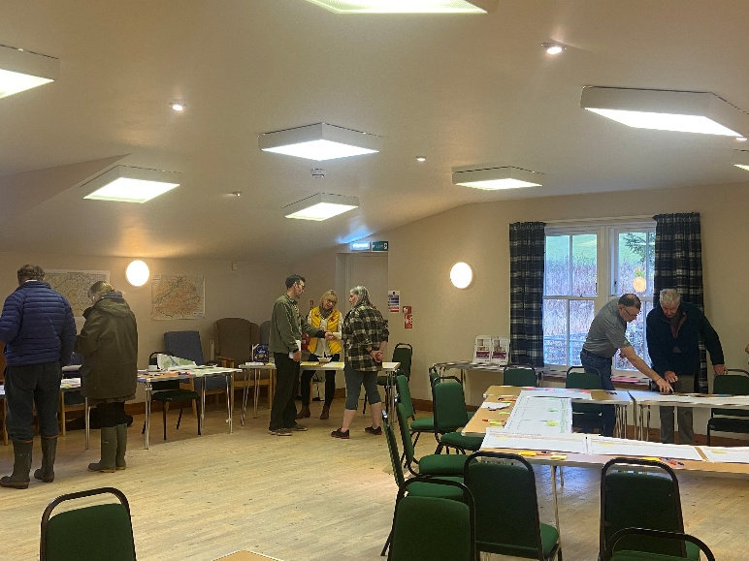 | 